UK Greenhouse Gas Emissions Project Documentation
This document will serve to highlight my thought process during the project, as well as being a record of the steps I took to reach my end results.
Project Overview

Project Aim
To develop my data cleansing, transformation, interrogation and visualisation skills by performing an end-to-end analysis process on the chosen dataset.
Throughout the project, I will be paying close mind to the limitations of my knowledge, and attempting to expand my skills via targeted research in these areas of weakness.
Dataset
For this project, I will be working with the “2005 to 2020 local authority greenhouse gas emissions” dataset provided by the Department for Business, Energy and Industrial Strategy, available on the data.gov.uk website:
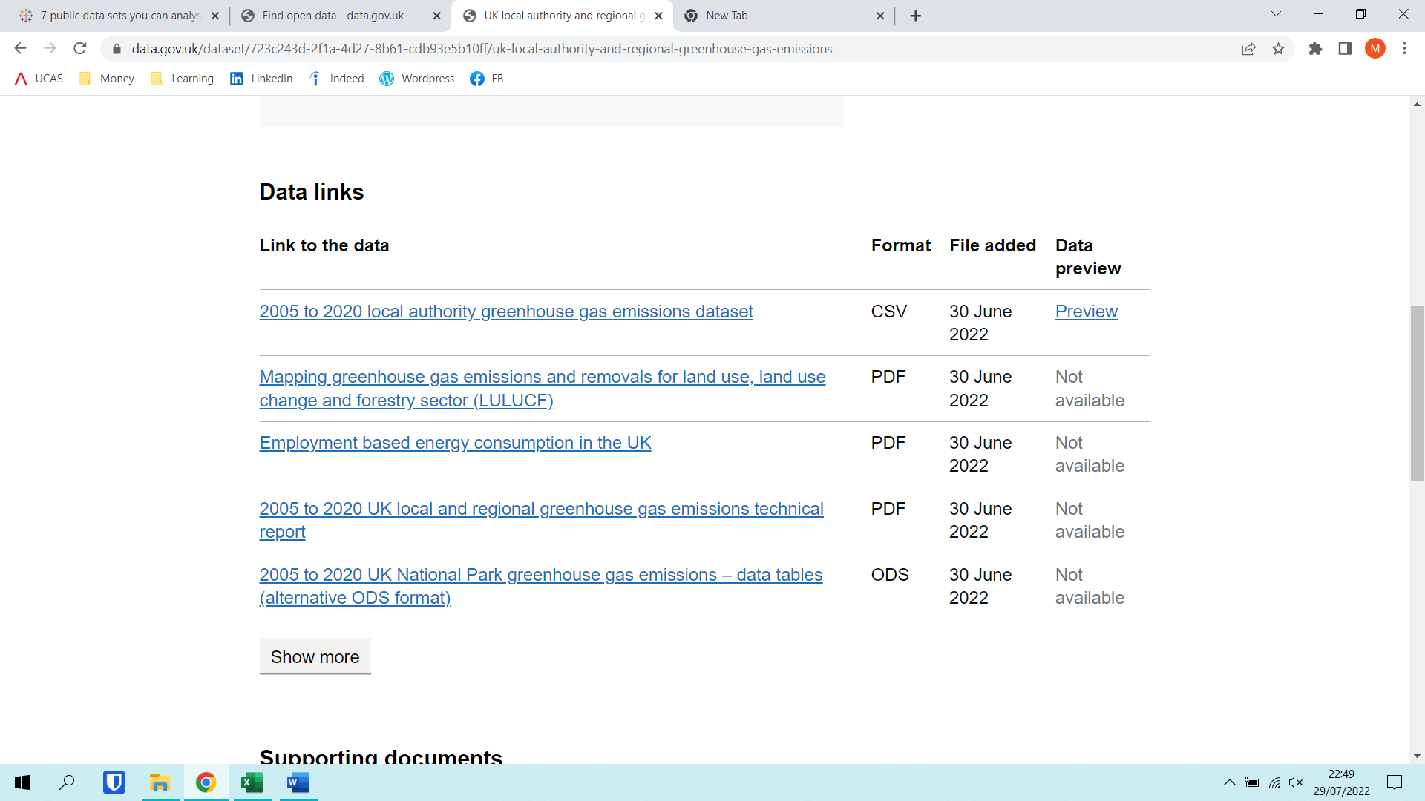
https://www.data.gov.uk/dataset/723c243d-2f1a-4d27-8b61-cdb93e5b10ff/uk-local-authority-and-regional-greenhouse-gas-emissions
I selected this dataset because I am keenly interested in environmental issues, specifically carbon neutrality, and wanted to improve my understanding of the topic on a national scale. The dataset contains data on three prevalent greenhouse gases: carbon dioxide (CO₂), methane (CH₄), and nitrous oxide (N₂O).
This data is from a reliable source (a department of the UK government), who itself sourced the data from the “UK National Atmospheric Emissions Inventory” and the “BEIS National Statistics of energy consumption for local authority areas”.
This dataset consists of 15 columns and 467,444 rows, and thus is sufficiently large so as to prevent thorough analysis being undertaken using solely Excel, and thereby requiring the use of tools better suited to large datasets, which I will discuss on the next page.
Research and Preparation
My first step when approaching the dataset was to browse through the accompanying documents on the source website. The document I found most useful was the Technical Report, which provided expansive information on the purpose and collection of the data. This was crucial in building up my background knowledge on the dataset; however, I recognise that this was a privilege and that in practice data analysts rarely have access to pre-existing documentation on datasets.
My next step was to draft a template of this project documentation, outlining what I wanted to include and how to organise it into a clear format. To do this, I took inspiration from my previous experience documenting school projects, as well as considering how I could best demonstrate my thought process throughout the data analysis process.

Key Questions
During my preparatory research for this project, one facet of the data analysis process that I often saw mentioned was the requirement to thoroughly understand the client’s needs, and their motivations for submitting their data for analysis. With respect to this, I formulated a number of key questions intended to simulate a client’s required output from a project such as this:

- How does the quantity of greenhouse gas (GHG) emissions vary across different regions of the UK?

- How does the quantity of GHG emissions vary across different industries/sectors?

- How have the quantity and type of GHG emissions changed over time (2005 – 2020)?

- Is there a relationship between GHG emissions of a region and population?

I will use these questions as a measure of success for this project, aiming to provide answers to all four questions. My answers will encompass both concise overviews as well as detailed descriptions, the combination of which will allow actionable insights to be drawn from the data. These actionable insights could then be used to influence and support decisions, for example drafting of new policies, made by the client.

Software
Once I had defined my goals for this project, I needed to decide which software would be best suited to achieving them. I will be utilising the following software in the course of this project:
- Excel (including Power Query) – for storage, data cleansing, and initial high-level analysis
- Python – to transport the data from Excel to an SQL database
- MySQL – to perform detailed analysis and interrogation
- Power BI and Tableau – to convey my insights clearly via data visualisations
- Word – to record my progress and highlight my learning, via this project documentation
Understanding and Cleaning the Data

Viewing and Cleaning
The first step was to obtain the data from the source and present it in a way that was easy to see. I downloaded the dataset from the source as a CSV file, then used the “Get data” and “Transform” options in Excel to load the data into Power Query. This allowed me to clearly observe the data in table format, while leaving the original CSV file unchanged.
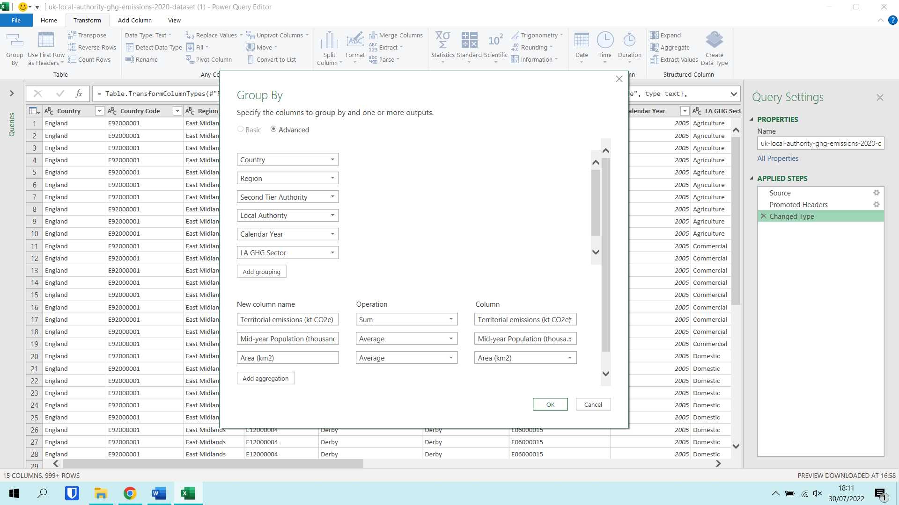
With the data in Power Query, I could begin to get a feel for the dataset I was dealing with. Immediately I noticed that some of the columns in the table were redundant for my project. The codes for country, region and local authority were not useful to me, since they do not correspond to real-life information (similar to surrogate keys). The “CO2 emissions within the scope of influence of LAs” column was also not useful to me, since my key questions did not relate specifically to this type of emissions, but rather to overall GHG emissions. “LA GHG Sub-sector” was also not a focus of my analysis, since my key questions related to industries/sectors in general.

To clean the data, I used the “Group By” function in PQ to remove unnecessary columns, and to sum the territorial emissions values for each GHG for each industry. This resulted in a table with fewer columns, which was easier and more efficient to work with. It also combined all sub-sectors in each sector into one row, giving emission information for the sector as a whole.

Once I had simplified the table, I used the filter options to check for erroneous values. I noticed some rows had “Unallocated” in the country and other geographical columns. However, I opted to leave these rows because they represented emissions from sources with unknown location, which could be useful when considering overall UK emissions. I used the “Remove Duplicates” function to check for and discard duplicate rows in the table (however none were found). I then renamed the table “Emissions” to make it easier to reference for pivot tables and formulae.
Some rows had negative values in the territorial emissions column, however by considering the context of the data I determined they were not errors. They corresponded to LULUCF (Land Use, Land Use Change and Forestry), which can be a net sink of CO2 - if the volume of CO2 taken in from the atmosphere by plants, and incorporated into organic molecules, is greater than the volume released by respiration. The greater the magnitude of the (negative) emissions value, the greater the Net Primary Productivity of the ecosystem.

Initial Analysis
Now that my data had been cleaned, I was ready to begin my initial analysis using Excel.
I wanted a general overview of how the GHG emissions varied between countries, types of GHG, years and sectors. To obtain this, I created several pivot tables and a variety of basic graphs:

Based on this bar chart, it was evident CO2 was the most prevalent GHG, and England was the highest contributor to emissions, across the whole time period.

This line graph shows a general trend of decreasing emissions across the time period.

This pie chart shows the percentages of the total emissions across the time period contributed by each sector.
Clearly transport, domestic and industry were the leading contributors.

Analysing the Data
Transporting the Data to MySQL
Before I could begin the detailed analysis process, I needed to transfer the cleaned data from Excel to MySQL. First, I created a new database via the MySQL Command Line Client, and connected this to PopSQL (a text editor).
Next, I planned my python code, focussing on the functions I would need. This gave me a list of modules I needed to install. To do this, I used pip, via the Windows Command Prompt.
Next, I created a python file that would read the data from the Excel file and replicate it in a table in the MySQL database: 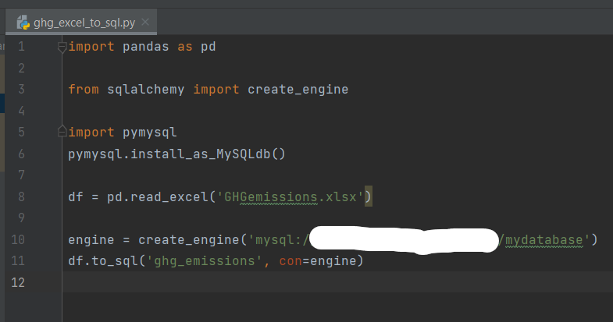
Importing the pandas module enabled python to read the Excel file (by calling the read_excel function) and store the data as a DataFrame. sqlalchemy and pymysql facilitated integration of the DataFrame into the MySQL database.
This stage required significant research due to my limited knowledge in python – I encountered numerous errors involving the engine variable, which I solved by referencing other people’s questions (mainly on Stack Overflow) as well as articles.

Modification using MySQL
With the data now stored in a table (“ghg_emissions”), I needed to ensure it had been correctly imported. First, I renamed the table to make querying more efficient:

Next, I viewed the table and counted the rows to ensure the full table had been imported:
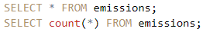

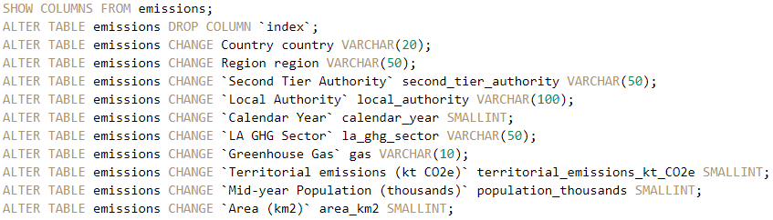
I then removed the unnecessary “Index” column, and renamed and changed the data types of the remaining columns:

The use of small integers, and specifying string length of varchars, optimises use of computer resources, which is something I had not considered prior to this project. I found out that using data types that are much larger than the values in the column wastes storage space. When working with a large/multiple databases, these optimisations are essential because they make storing and working with the data much more efficient.

Querying using MySQL
The next stage was to extract meaningful insights from the data by querying the table:

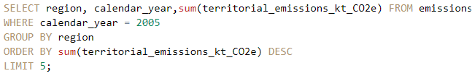

For the majority of the time period, the regions with the greatest annual emissions were the South East, North West, and Yorkshire and the Humber.
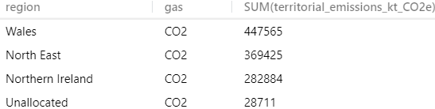
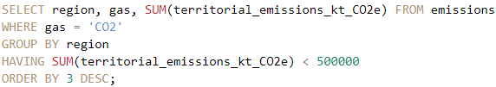

3 regions had total CO2 emissions of less than 500,000 ktCO2e.
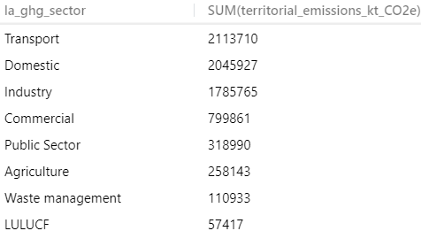
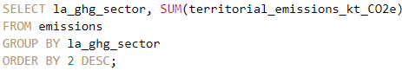

Visualisations
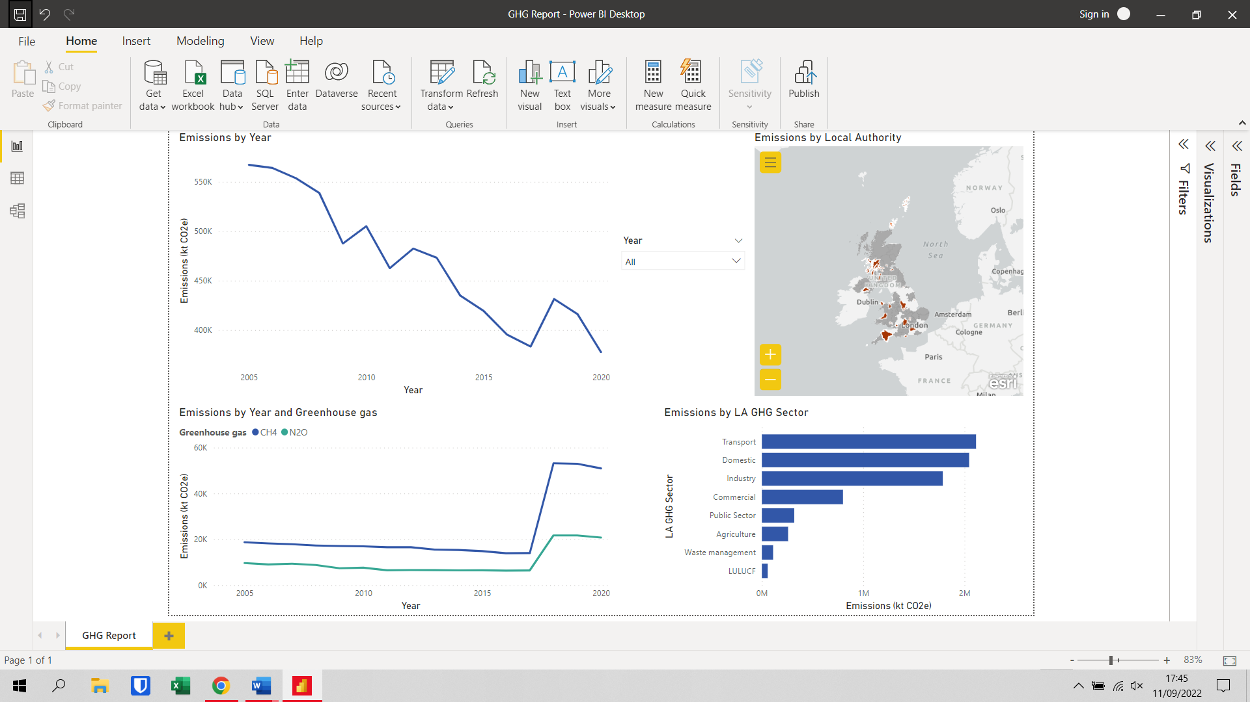
I now needed to create a dashboard to convey my insights in an easily digestible fashion. For this task, I used a combination of Power BI and Tableau.
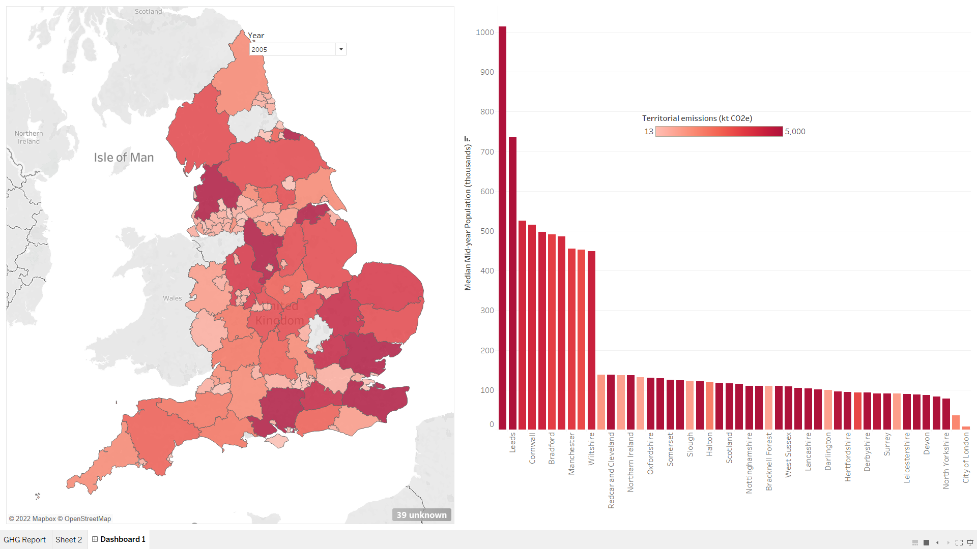

I would use these concise visualisations to support my analysis and convey my conclusions to stakeholders via in-person or online presentations.

Conclusions
As stated in the Project Overview section at the beginning of this document, successful completion of this project will be measured by the strength of my answers to the four Key Questions posited in the aforementioned section:

- How does the quantity of greenhouse gas (GHG) emissions vary across different regions of the UK?

England was by far the country that was the largest contributor to emissions over the entire period. The regions with the highest emissions were generally the South East, North West, and Yorkshire and the Humber. Wales, the North East, and Northern Ireland had the lowest total emissions over the time period.

- How does the quantity of GHG emissions vary across different industries/sectors?

The three industries with the greatest total emissions were transport, domestic, and industry. LULUCF was the sector with the lowest emissions, however this can be attributed to Net Primary Productivity, which I explained in the data cleaning and viewing section of this document. Other than this, waste management was the lowest contributor to emissions.

- How have the quantity and type of GHG emissions changed over time (2005 – 2020)?

The line charts I created show a clear decrease in emissions over the time period. There were some years where emissions increased year-on-year, eg 2010 and 2018, however these do not change the overall trend. Both NO2 and CH4 emissions remained relatively constant from 2005 – 2017, saw a sharp increase in emissions between 2017 and 2018, then remained relatively constant once more from 2018 – 2020.

- Is there a relationship between GHG emissions of a region and population?

My bar chart shows that some high and some low population regions had high emissions. Small population regions tended to either have very high or very low emissions, whereas all of the 10 highest population regions had fairly high emissions. There does not appear to be a strong correlation between population and emissions of a region.

Evaluation
After reviewing my answers to my Key Questions, I feel this project was largely a success in terms of providing business value and generating actionable insights. My answers are clearly supported by data, and are defined in a concise way, which I believe would enable me to communicate them to non-technical audiences, with the help of the visualisations I created.
More importantly for this project, which did not have any real-world implications, the journey I took from raw data to end product gave me valuable practical experience of the entire data analysis process. My holistic approach to learning in this project has paid dividends in the form of an improved understanding and appreciation of the challenges faced by data professionals in their day-to-day work. The biggest benefactor has been my python knowledge – I had never previously used it to transfer data from excel to a database.
In spite of the valuable learning experience, I recognise that as a data analyst, choosing the most efficient tools for a particular task is vital. Because of this, I will assign the next step of my learning journey to familiarising myself with Microsoft SQL Server, due to its native integration with the Microsoft ecosystem. Had I used this in place of MySQL, I would have had no need to write a script in python, and could have simply imported the data straight from Excel.
As for my next project, I would like to incorporate more statistical analysis into my work (eg hypothesis testing, confidence intervals, modelling etc), as well as some forecasting, and basic machine learning methods.

